Selecting S3 from the storage of the AWS service panel

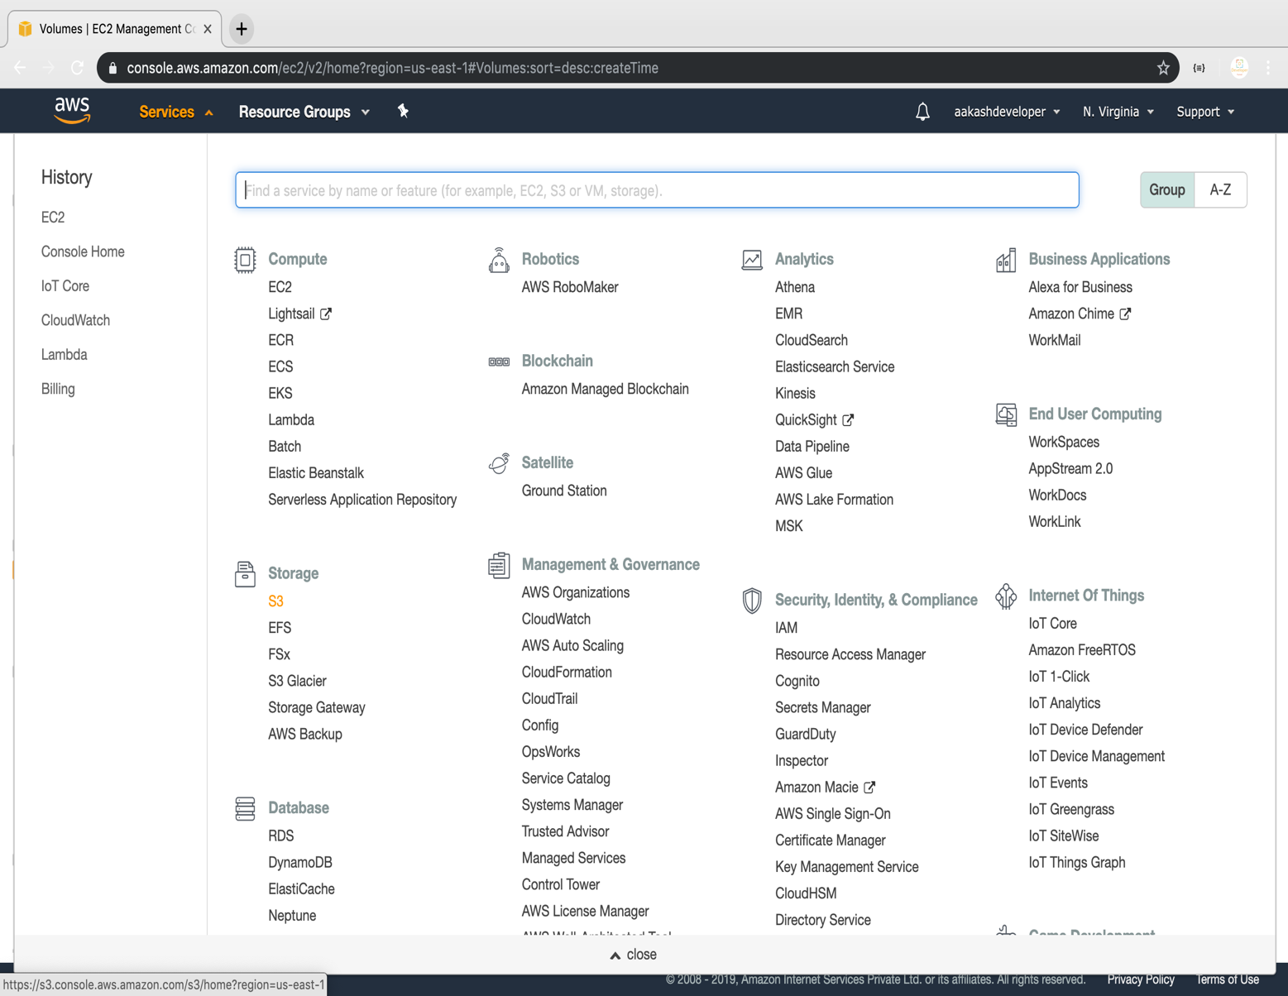

Verifying the button to create a bucket

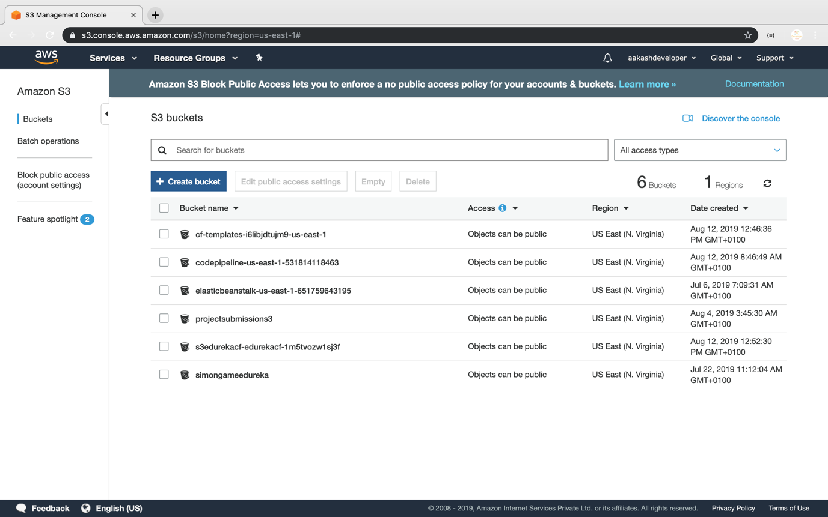

Providing a bucket name and region

* Make sure that the bucket name is unique

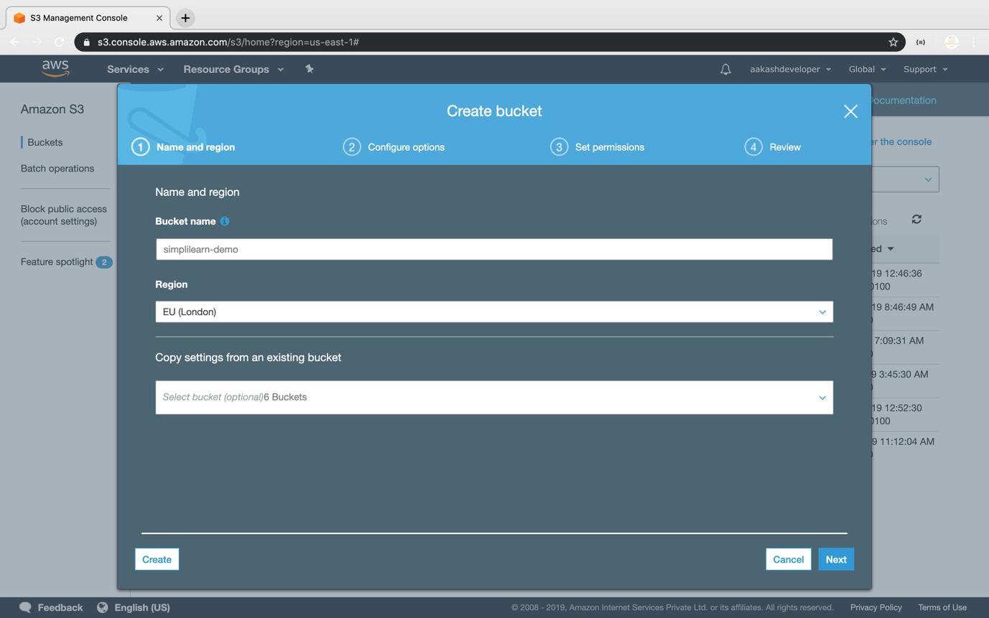

Entering key and value for identification and tracking the bucket

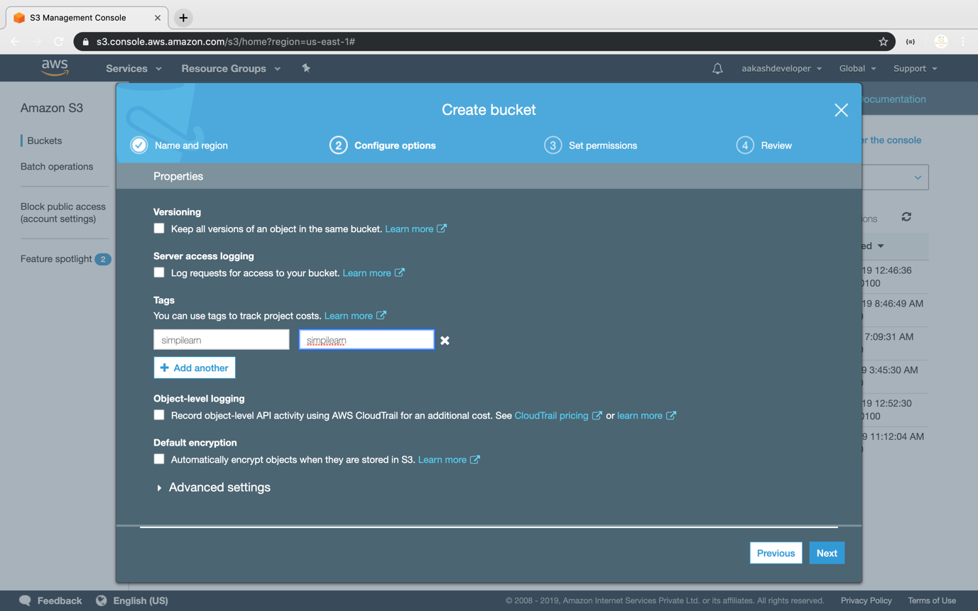

Blocking all the public access

* If required, you can configure it later

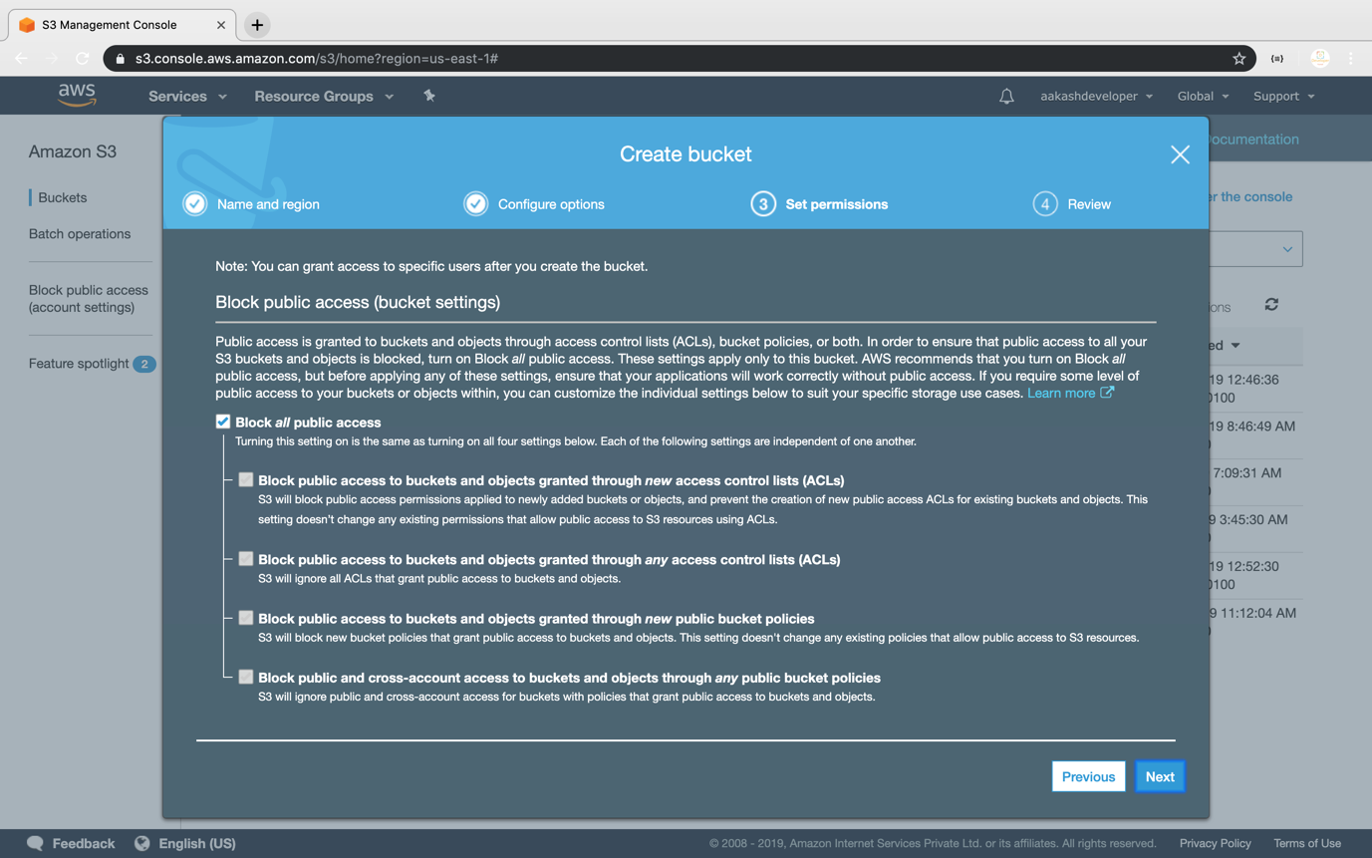

Reviewing all parameters and creating the bucket

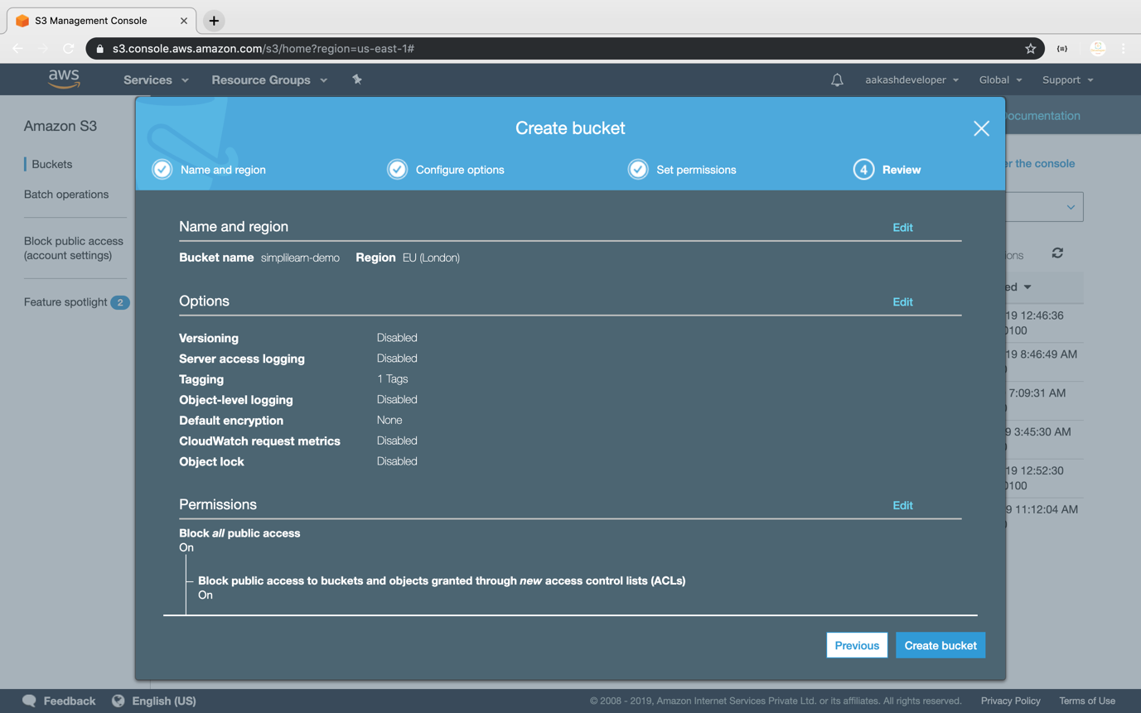

Verifying the newly created bucket on the panel of S3

